
Project Title: Student Registration System By: ULZIIBAT BYAMBADULAM
Lecturer:

Table of contents

S/N | Content | Page no
1 | Description of a Current business activities | 3
2 | Design Specification  2.1 Entity Specification  2.2 Attributes Specification  2.3 Relationship Specification  2.4 Constraints Specification | 4  5  7  8
3 | Normalisation | 8
4 | Entity Relationship Model Diagram | 10
5 | Critical Appraisal | 10

Current business activities
Nowadays, many universities, schools, kindergartens and education institutions manage information without database. Registration information, students’ personal information, class schedules and grades are handled through paper or simple spreadsheets manually.
Searching, updating and maintaining records are both time consuming and inefficient as it is prone to error and duplication.
Having a computerized data system will minimize these errors, increase accuracy and even save time.

Design Specification
2.1 Entity Specification
There are 3 main entities in the system
- Student
- Course
- Exam result.

- Student has 5 attributes:
Student id, student first name, student last name, email, phone, and gender.

- Course entity has three attributes :
Course id, course name, teacher name.

- The exam result entity has 3 attributes.

2.2 Attributes Specification

Attribute for student specification
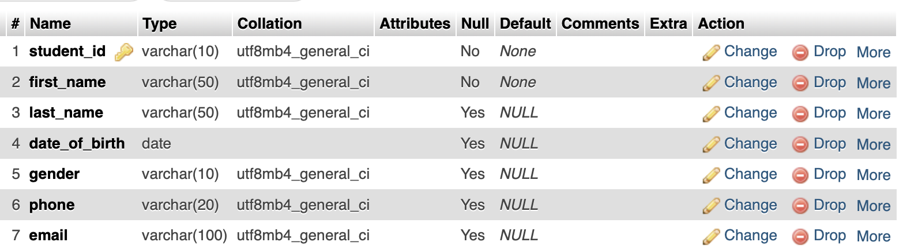

- Student _id
  - Limited to 10 characters and assigned as primary key
  - Range from 0000000000 to 9999999999
- First _name is allocated 50 characters
- Last name is allocated 50 characters
- Date of birth is allocated date.
- Gender is limited to 10 characters.
- Phone is limited to 20 characters.
- Email is limited to 100 characters.
Attribute for course specification
Course attribute

Course id is limited to 5 characters and assigned as primary key.
- Course name is limited 20 characters.
- Teacher name is limited to 20 characters.

Attribute for exam result specification
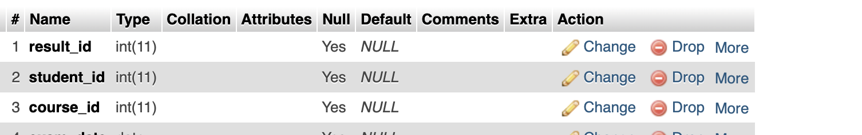
- Result id is limited to 11 integers.
- Student id is limited to 11 inetegers.
- Course is is limited to 11 integers.

2.3 Relationship Specification

- One student may attend many classes and classes must be attended by a
Students
First name
Student id

Email address

Student

1
Date of birth
Last name

Exam result
Exam result

Course name
Course id

m

Course

Teacher name

2.4 Constraints Specification
Composite Key ID is created consisting Student id, Course id and date. This must not be duplicated as a student could only appear in a course id on same date.
Student details must not be duplicated in the course entity.
Course details must not be duplicated in the student entity
Exam result details could only be identified by composite key (student id and course id). Course id in exam result entity must appear in the course entity and student id in exam result entity must appear in student entity.

Normalisation
UNF
Student  id | Student  First name | Student last | Student email | Course id | Course name | Teacher name | Result id | Exam date | Gender
1 | Bayar | Anujin | SG@gmail.com | C001 | DBMS | John | 11 | 2025-09-09 | F
2 | Bold | Ariun | GS@gmail.com | C002 | C Programming | Jane | 22 | 202509-10 | F
3 | Saraa | Anu | SG@gmail.com | C001 | DBMS | John | 33 | 2025-09-09 | F

UNF
STUDENT(student_id, student_first_name, student_last_name, student_email, gender, course_id, course_name, teacher_name, result_id, exam_date)
1NF
STUDENT
(student_id,(primary key,) course_id, student_first_name, student_last_name, student_email, gender, course_name, teacher_name, result_id, exam_date)
2NF
STUDENT
(student_id,(primary key), student_first_name, student_last_name, student_email, gender)
COURSE
(course_id,(primary key ) course_name, teacher_name)

ENROLLMENT
(student_id, course_id)

EXAM_RESULT (student_id, course_id, result_id, exam_date)

3NF
STUDENT
(student_id, student_first_name, student_last_name, student_email, gender)
TEACHER
(teacher_id, teacher_name)

COURSE
(course_id, course_name, teacher_id)
EXAM_RESULT
(student_id, course_id, result_id, exam_date)

Entity Relationship Model Diagram

student
course
exam result
1
1

m
exam

Critical Appraisal
The system is working and could help the to perform the following functions:
- Insert into course values(‘C001’, ‘DBMS’, ‘John’)
- Insert into course values(‘C002’, ‘C Programming’, ‘Jane’)



- Insert into student values(1, ’Bayar’, ‘Anujin’, ‘1993-12-12’, ’F’, ‘12345’, ‘SG@MAIL.COM’)
Insert into student values(2, ’Bold, ‘Ariun’, ‘1999-11-11’, ’F’, ‘62345’, ‘GS@MAIL.COM’)
Insert into student values(3, ’Saraa’, ‘Anu’, ‘1993-12-12’, ’F’, ‘12345’, ‘SG@MAIL.COM’)

- insert into exam_result values(‘C0001’,’1’,’2025-09-10’, ‘2025-09-10’)
- insert into exam_result values(‘C0002’,’2’,’2025-09-11’, ‘2025-09-11’)
- insert into exam_result values(‘C0001’,’3’,’2025-09-10’, ‘2025-09-10’)
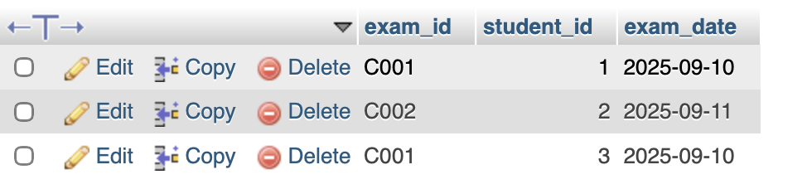

Conclusion
In conclusion, the Student Registration System achieved its main purpose of organizing students, courses, and registrations successfully. The database design follows proper normalization rules, ensuring reliability and lowering data duplication.
While the system is limited to basic database operations, it serves as a solid base for further improvoment. Future improvements may include security features and reporting analytics to support more advanced academic management needs.

